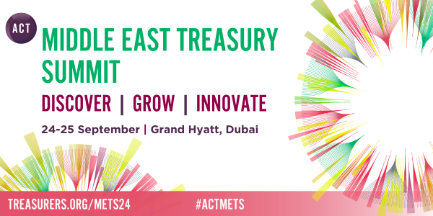

Dear [recipient name],

I am writing to express my interest in attending the **ACT Middle East Treasury Summit 2024** at **Grand Hyatt** on **224-25 September.**

The conference will help me to achieve [insert your objective for attending the conference here] by [insert how the conference will help you achieve your objective].

The ACT Middle East Treasury Summit brings together hundreds of treasury and finance professionals to discover the latest in treasury.

Attending the ACT Annual Conference provides a wide range of benefits and would help us to:

* Prepare for upcoming challenges and ensure you are equipped to navigate the complex and uncertain environment that treasurers operate in
* keep up to date with the latest developments in treasury
* learn from 60+ expert speakers and gain practical advice and insights on specific regional challenges
* build my professional network and meet with 25+ new and existing suppliers in the exhibition hall
* discover what your peers and competitors to help ensure we stay one step ahead of the competition.

I look forward to taking advantage of the opportunities that the conference offers and sharing insights with key stakeholders when I return.

Thank you for considering my request. I look forward to hearing from you.

Kind regards,

[sender name]